Clean Code Principles - Command Query Separation (CQS)
# Source: AI Source: Provided by: [Data Path: Persons Table -> ID Column: 1, Name_En Column: Motasem Essam] -> From: [Chatgpt (GPT‑5 Mini)] on [12/9/2025]
Command Query Separation (CQS) states that a function should be either:
- Command → performs an action (changes state)
- Query → returns data (without changing anything)
👉 A function should not do both at the same time

🔑 Why It Matters
# Source: AI Source: Provided by: [Data Path: Persons Table -> ID Column: 1, Name_En Column: Motasem Essam] -> From: [Chatgpt (GPT‑5 Mini)] on [12/9/2025]
- Makes code easier to understand
- Prevents unexpected side effects
- Improves predictability
- Simplifies testing and debugging

❌ Bad Example (Mixing Command + Query)
# Source: AI Source: Provided by: [Data Path: Persons Table -> ID Column: 1, Name_En Column: Motasem Essam] -> From: [Chatgpt (GPT‑5 Mini)] on [12/9/2025]
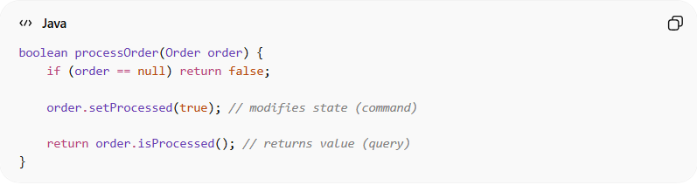
boolean processOrder(Order order) {
if (order == null) return false;

order.setProcessed(true); // modifies state (command)

return order.isProcessed(); // returns value (query)
}
👉 Problems:
- Function both changes state and returns data
- Hard to know what the function really does
- Can cause unexpected behavior

✅ Good Example (Separated Responsibilities)
# Source: AI Source: Provided by: [Data Path: Persons Table -> ID Column: 1, Name_En Column: Motasem Essam] -> From: [Chatgpt (GPT‑5 Mini)] on [12/9/2025]
✔️ Command
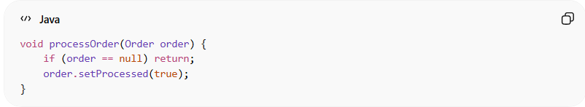
void processOrder(Order order) {
if (order == null) return;
order.setProcessed(true);
}
✔️ Query
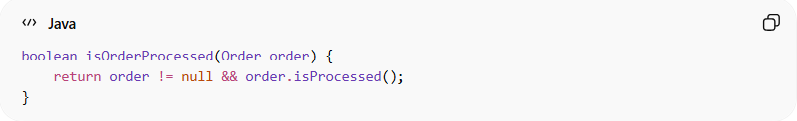
boolean isOrderProcessed(Order order) {
return order != null && order.isProcessed();
}
👉 Clear separation:
- One function modifies state
- One function returns data

❌ Another Bad Example
# Source: AI Source: Provided by: [Data Path: Persons Table -> ID Column: 1, Name_En Column: Motasem Essam] -> From: [Chatgpt (GPT‑5 Mini)] on [12/9/2025]
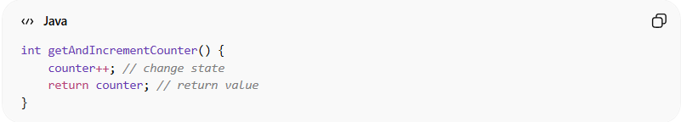
int getAndIncrementCounter() {
counter++; // change state
return counter; // return value
}

✅ Good Example
# Source: AI Source: Provided by: [Data Path: Persons Table -> ID Column: 1, Name_En Column: Motasem Essam] -> From: [Chatgpt (GPT‑5 Mini)] on [12/9/2025]
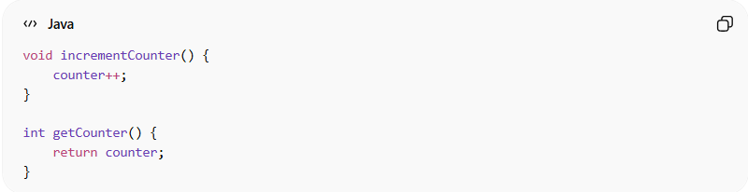
void incrementCounter() {
counter++;
}

int getCounter() {
return counter;
}

💡 Key Idea
# Source: AI Source: Provided by: [Data Path: Persons Table -> ID Column: 1, Name_En Column: Motasem Essam] -> From: [Chatgpt (GPT‑5 Mini)] on [12/9/2025]
Ask yourself:
“Is this function doing something or answering something?”
It should not do both.

🚫 Common Mistakes
# Source: AI Source: Provided by: [Data Path: Persons Table -> ID Column: 1, Name_En Column: Motasem Essam] -> From: [Chatgpt (GPT‑5 Mini)] on [12/9/2025]
- Functions that update data and return results
- Hidden side effects inside getter-like methods
- Mixing logic and state changes

🧾 Summary
# Source: AI Source: Provided by: [Data Path: Persons Table -> ID Column: 1, Name_En Column: Motasem Essam] -> From: [Chatgpt (GPT‑5 Mini)] on [12/9/2025]
CQS helps you:
- Write clear and predictable code
- Avoid side effects
- Improve readability and maintainability
- Make functions easier to test

